Integration – Volume
To find volume generated by rotating a shape about the x-axis $Vol= \int_{a}^{b}{πy^{2}}$

Example 1
The graph of $y=x^{2}$ between $x=1$and $x=3$ is rotated completely about the x-axis. Find the volume generated.
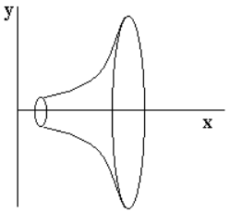 | $\int_{1}^{3}{π}x^{4}dx = π\frac{x^{5}}{5}+c between 1 and 3$ =  $= π(\frac{{\left(3\right)}^{5}}{5}$ – $\frac{{\left(1\right)}^{5}}{5})$ = $\frac{243π}{5}- \frac{π}{5}$ = $\frac{242π}{5}=48.4π {units}^{3}$

Example 2
Determine the volume of the solid generated by rotating the region bounded by $f\left(x\right)=x^{2}-4x+5, x 1, x 4$and the x-axis about the x-axis.

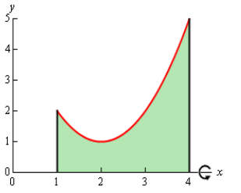 | 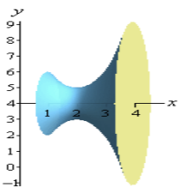

$\int_{1}^{4}{π}{{(x}^{2}-4x+5)}^{2}dx = π{(x}^{4}-8x^{3}+26x^{2}-40x+25+c) between 1 and 4$ =

$= π((\frac{{\left(4\right)}^{5}}{5}$ – $\frac{{8\left(4\right)}^{4}}{4}+\frac{{26\left(4\right)}^{3}}{3}-\frac{{40\left(4\right)}^{2}}{2}+25\left(4\right)+c)$ – ($\frac{{\left(1\right)}^{5}}{5}$ – $\frac{{8\left(1\right)}^{4}}{4}+\frac{{26\left(1\right)}^{3}}{3}-\frac{{40\left(1\right)}^{2}}{2}+25\left(1\right)+c$))
$=π((\frac{1024}{5}$ – $\frac{2048}{4}+\frac{1664}{3}-\frac{460}{2}+100+c$ $-\frac{1}{5}$ + $\frac{8}{4}-\frac{26}{3}+\frac{40}{2}-25-c$))
$=π((\frac{1024}{5}$ – $512+\frac{1664}{3}-130+100+c$ $-\frac{1}{5}$ + $2-\frac{26}{3}+20-25-c$))
= $\frac{78π}{5} {units}^{3}$

