Integration – Area & Volume Exercises
By using a definite integral find the area of the region bounded by the given curves:
Questions | Answers
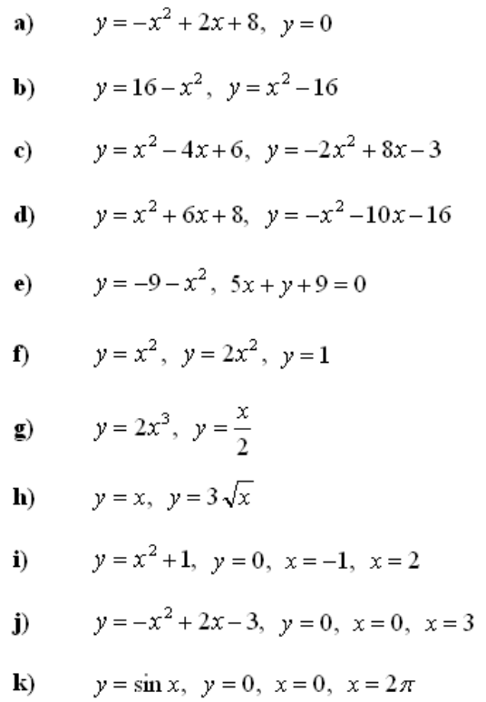 | 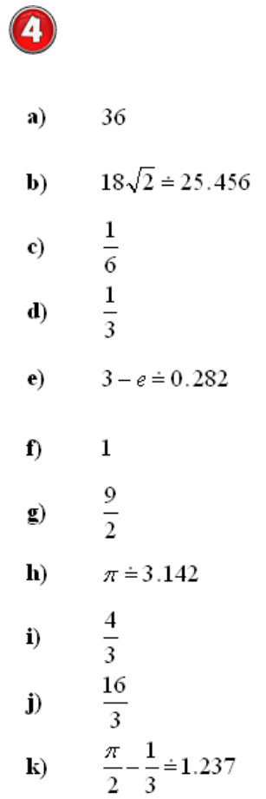

5 By using a definite integral find the volume of the solid obtained by rotating the region bounded by the given curves around the x-axis :
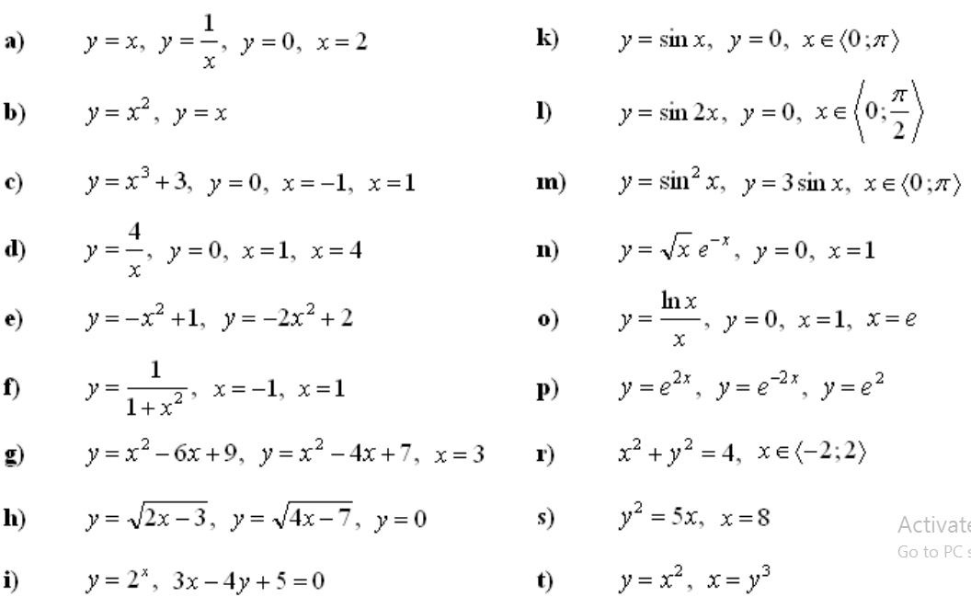
Answers
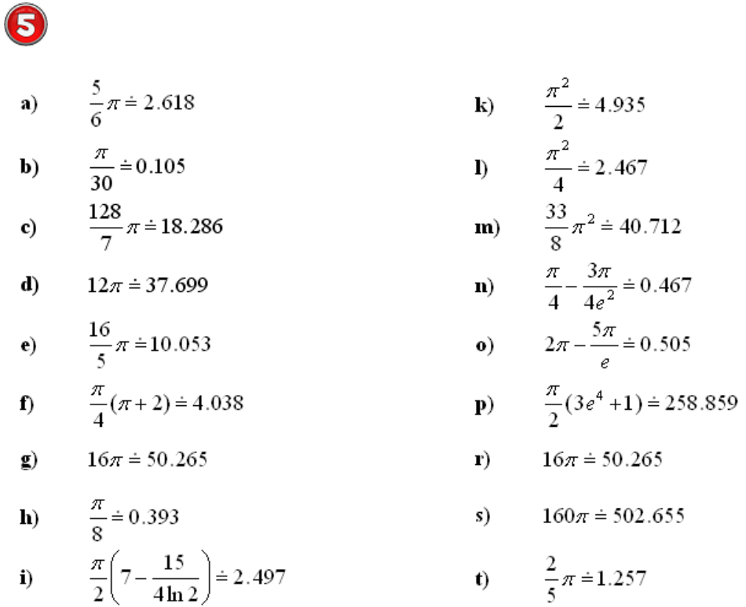

6 By using a definite integral find the volume of the solid obtained by rotating the region bounded by the given curves around the y-axis :
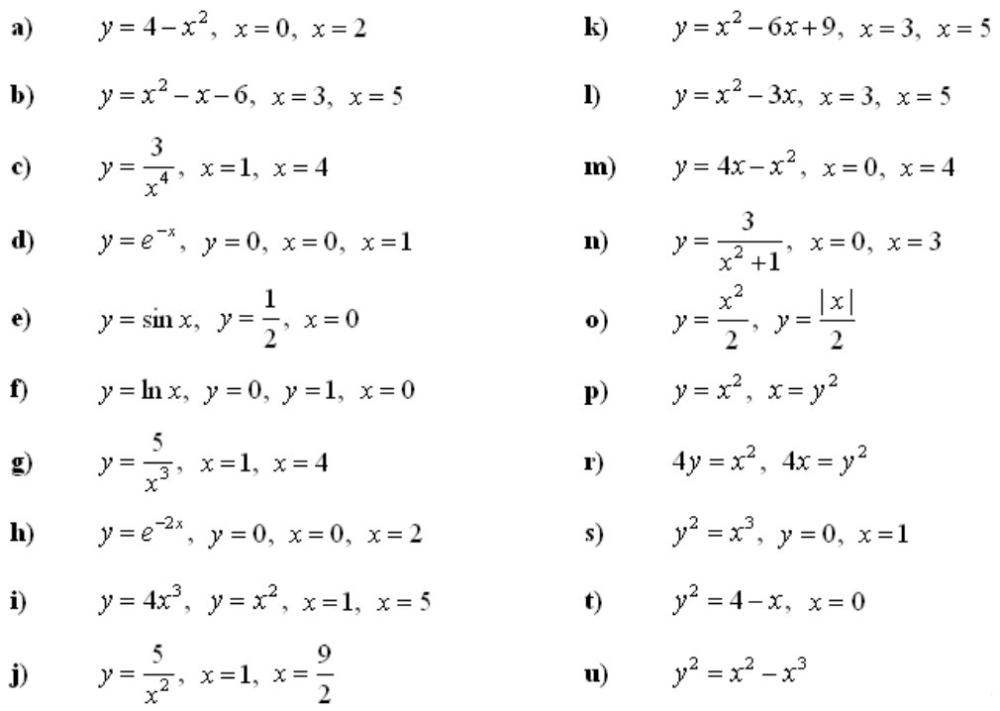
Answers
