Calculus – Differentiation
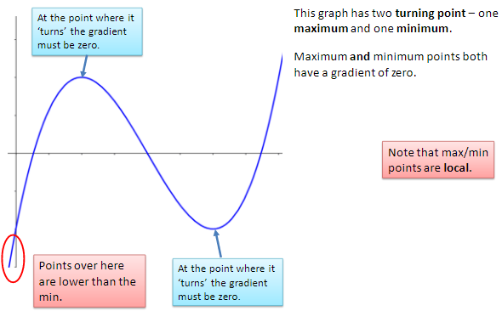
Maximum, Minimum Points of Inflection
The value f '(x) is the gradient at any point but often we want to
find the Turning or Stationary Point (Maximum and Minimum
points) or Point of Inflection
These happen where the gradient is zero, f '(x) = 0.
- f ''(x) is negative the function is maximum turning point
- f ''(x) is zero the function may be a point of inflection
- f ''(x) is positive the function is minimum turning point

Example
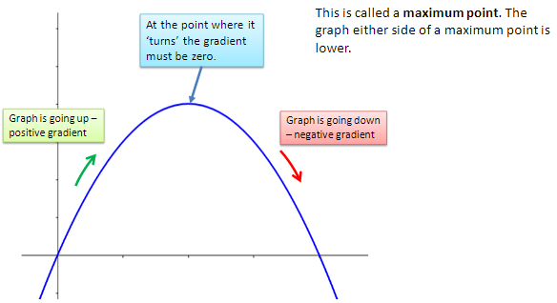
Find the maximum and minimum points of
- ${f\left(x\right)=2x}^{3}-{3x}^{2}-6$
Differentiate twice as follows
- ${f^{I}\left(x\right)=6x}^{2}-6x$
- ${f^{II}\left(x\right)=}^{ } 12x-6$
Turning points at $f^{I}\left(x\right)=0$ therefore
- ${6x}^{2}-6x=0$
- $6x(x-1)=0$
- $6x=0 or (x-1)=0$
- $x=0 or x=1$
Substituting x values into the function f(x)
- ${f\left(0\right)=2(0)}^{3}-{3\left(0\right)}^{2}-6 therefore f\left(x\right) or y=-6. Point (0,-6)$
- ${f\left(1\right)=2(1)}^{3}-{3\left(1\right)}^{2}-6 therefore f\left(x\right) or y=-7. Point (1,-7)$
Determining which is max/min
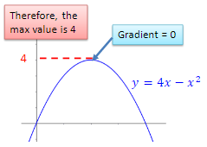
- ${f^{II}\left(0\right)=}^{ } 12\left(0\right)-6=-6$ (Maximum)
- ${f^{II}\left(1\right)=}^{ } 12\left(1\right)-6= 6$ (Minimum)
Maximum and minimum points
- Maximum turning point = $(0,-6)$
- Minimum turning point = $(1,-7)$

Exercise
- Find the turning points of the following and determine the maximum or minimum
  - ${f\left(x\right)=x}^{2}-2x-2$
  - ${f\left(x\right)=x}^{3}-{6x}^{2}+9x-2$

- The diagram shows a rectangular enclosure with a wall forming one side. A rope 20m long is used to form the remaining 3 sides. The width of the enclosure is x metres. Find the maximum length of x which gives the maximum area. Hence find the maximum area. You can call the length of the enclosure y.
Solution to 2 on next page

More exercises (answer on next page)
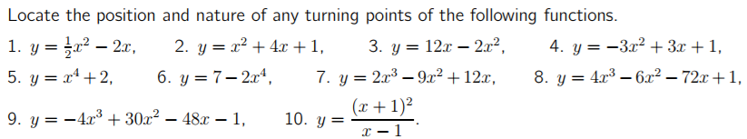

Solution to 2
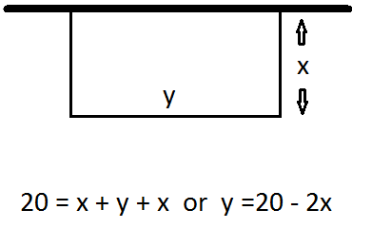
Area $=xy$
Area $=x(20-2x)$
$={20x-2x}^{2}$ This is the equation for graph of area against width
Maximum or minimum area occurs where $\frac{dA}{dx}=0$
- $\frac{dA}{dx}=20-4x$
- $20-4x=0$
- $20=4x$
- $5=x$
Maximum Area
- $\frac{d^{2}A}{dx^{2}}=-4$
Area in metre²
$$5\left(20-2\left(5\right)\right)=$$
$$5\left(20-10\right)=$$
$$5\left(10\right)=$$
$$Area=50m^{2}$$

Answers to exercises on previous page
