4-1 Key concepts of calculus including limits, differentiation and integration
Applications of Differentiation
- Slope of a line/tangent to a curve/graph/function
- Calculating speed
- Calculating acceleration
Applications of Integration
- Calculating Area (eg area under a curve between x-axis and two x values)
- Calculating Volume based and generating a rotation about the x-axis or y-axis
Fundamental Theorem of Calculus
Video: https://www.khanacademy.org/math/integral-calculus/fundamental-theorem-of-calculus-ic/modal/v/fundamental-theorem-of-calculus
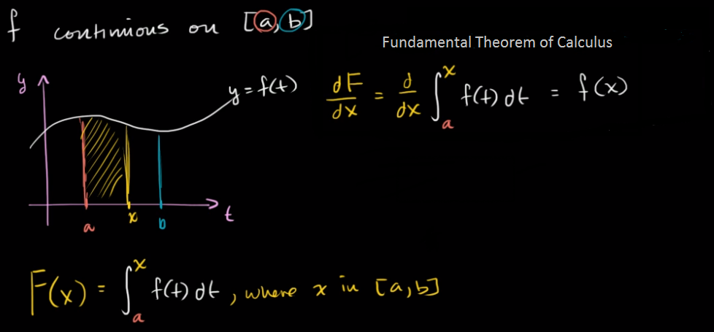
Differentiation
The Definition of Differentiation: The essence of calculus is the derivative. The derivative is the instantaneous rate of change of a function with respect to one of its variables. This is equivalent to finding the slope of the tangent line to the function at a point
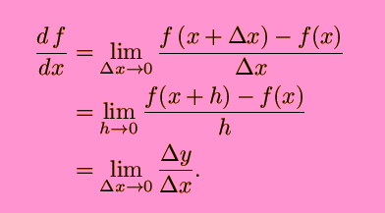

Differentiation Rules
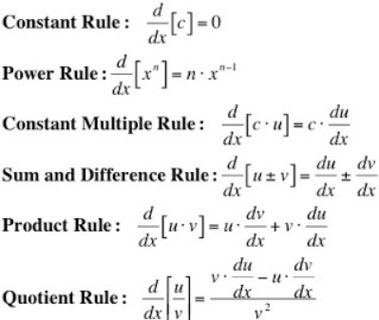

Integration
Integration is used to find areas under curves. Integration is the reversal of differentiation hence functions can be integrated by indentifying the anti-derivative.
However, we will learn the process of integration as a set of rules rather than identifying anti-derivatives.
Terminology
- Indefinite and Definite integrals
There are two types of integrals: Indefinite and Definite.
Indefinite integrals are those with no limits and definite integrals have limits.
When dealing with indefinite integrals you need to add a constant of integration. For example, if integrating the function f(x) with respect to x:
∫(f x) dx = g(x) + C , where g(x) is the integrated function.
- C is an arbitrary constant called the constant of integration.
- dx indicates the variable with respect to which we are integrating, in this case, x.
- The function being integrated, f(x), is called the integrand.

Rules on next page – see Log Tables/Mathematics Tables
