Linear Models
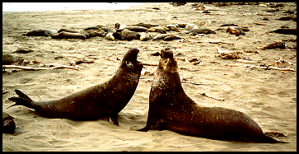
Barren Island
The mathematical title of this module is Linear Models. We use the term "linear" in this module in a different way than in the preceding module.
These models can fulfill many different purposes in the middle and high school curriculum. They are simple, yet rich, and can be used to help students learn some very important mathematics. In particular, they lend themselves to numerical, graphical, and symbolic study. Graphs involving linear models are very easy to draw by hand and give students a solid foundation for working with graphs later that are best drawn using a computer or graphing calculator. In addition, linear models are used to study many important real-world phenomena. We look at three examples.
- Population models involving immigration.
- Supply and demand models for changing prices.
- The natural cleaning of a polluted lake.
Population Models Involving Immigration
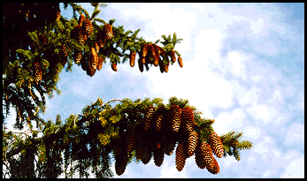
Lush Mainland
We begin with a barren island off the coast of a lush mainland. We are interested in a particular species of birds that nests on this island. Unfortunately the island habitat is so unfavorable that if the birds were isolated on the island their population would drop 20% each year and could be described by the exponential model.
p_{n+1} = 0.80 p_{n}.
There is a thriving colony of birds on the nearby lush mainland and each year 1,000 birds from the lush mainland migrate to the barren island. Thus, the population change on the island can be described by the model
p_{n+1} = 0.80 p_{n} + 1,000.
Notice that this is a linear model in the sense that we are using the word "linear" in this module and from now on.

- Compute and graph p₂, p₃, ... p₁₀ for this model with the initial condition
p₁ = 50.
- Compute and graph p₂, p₃, ... p₁₀ for this model with the initial condition
p₁ = 500.
- Compute and graph p₂, p₃, ... p₁₀ for this model with the initial condition
p₁ = 10,000.
- Describe the long term behavior of the bird colony on this island.

We can write this model as
p_{n+1} = f(p_{n})
or
p_{n} = f(p_{n-1})
where
f(p) = 0.80 p + 1,000
This is a particularly good way of looking at this model because it focuses our attention on the function
f(p) = 0.80 p + 1,000
that describes how each year's population is determined by the population during the preceding year. Notice that this function is linear. This is the reason that this kind of model is called a linear model.
The graph below shows the function f(p) in red and the function g(p) = p in black. The function g(p) = p is the function we would use if the population did not change from one year to the next.
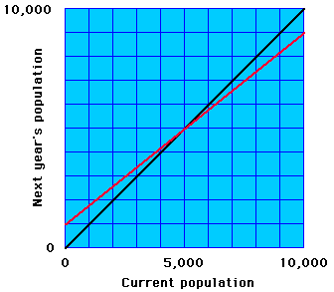
Notice that the two graphs cross at the point p = 5,000. This point is called an equilibrium point because next year's population is the same as the current population.
The graph above shows how we can determine this equilibrium point graphically by finding the point at which the function f(p) crosses the diagonal line g(p). This determination can be very accurate since the graph of f(p) is a straight line and thus is easy to draw.
We can verify that p = 5,000 is an equilibrium point numerically by computing
f(5,000) = 0.80 * 5,000 + 1,000 = 4,000 + 1,000 = 5,000
and we can find this equilibrium point algebraically by solving the equation
p = f(p)
p = 0.80 * p + 1,000
0.20 * p = 1,000
p = 5,000

For each of the following linear models find the equilibrium point graphically and algebraically and verify that your answer is correct numerically.
- p_{n} = 0.90 p_{n-1} + 1,000
- p_{n} = 0.90 p_{n-1} + 500
- p_{n} = 0.75 p_{n-1} + 1,000
- p_{n} = 0.75 p_{n-1} + 500
- p_{n} = 1.2 p_{n-1} + 1,000
- p_{n} = m p_{n-1} + b, where m and b are constants.
- In the exercise above if b is positive, for what values of m is the equilibrium point positive and for what values of m is the equilibrium point negative?
- In the first chapter we looked at supply and demand models. Suppose the supply function and the demand function for a particular product are given by
S(p) = 1000 p - 400
D(p) = 5000 - 500 p
where p denotes price. Suppose that the change in prices is described by the discrete dynamical system
p_{n} = p_{n-1} + k(D(p_{n-1}) - S(p_{n-1}))
where k is a positive constant. Show this is a linear model and find its equilibrium point. Show that the equilibrium point is the price at which supply and demand are equal.

The Natural Cleaning of a Polluted Lake
Next we turn our attention to a lake that has been polluted. We suppose that the lake was polluted by someone who has been caught and that no additional pollutant will be added in the future. Suppose the present level of pollution is
p₁ = 20 ppm.
The abbreviation ppm stands for parts per million.
Suppose that our lake is part of a chain of lakes connected by rivers and that each year 10% of the water in the lake flows downstream and is replaced by clean water from the lakes upstream and from rainfall. This leads to the model
p_{n} = 0.90 p_{n-1}.

- Suppose that the people who polluted the lake were sued by the state and found guilty. The court has imposed a fine of $50,000 for each year that the lake is unsafe for swimming starting with the current year with the pollution level 20 ppm. An expert from the state university testifies that the lake is unsafe for swimming as long as the level of pollution is above 5 ppm. What fine will the company have to pay if the court accepts the expert's testimony?
- The company calls its own expert who testfies that it is perfectly safe to swim in the lake when the level of pollution is below 15 ppm. What fine will the company have to pay if the court accepts the company's expert's testimony?
- An environmental group called Friends of the Lake files a friend of the court brief in which they argue that the company's expert is not impartial. She has earned a fair amount of money traveling around the country testifying on behalf of convicted polluters and being paid for her testimony. Friends of the Lake also argues that even the university expert's testimony is suspect because his university has accepted several research grants from the polluter's parent company. His testimony did not mention that pregnant women are particularly sensitive to this pollutant. Friends of the Lake files a report by a third expert who argues that the safe level of pollution is 1 ppm. What fine will the company have to pay if the court accepts this argument?

In practice, the water flowing into a lake like the lake above is rarely completely free of the pollutant. If the level of pollution in the water flowing into the lake is b ppm then the model above would be replaced by
p_{n} = 0.90 p_{n-1} + 0.10 b.

Explore the model above.
- Begin by looking at the model given by
p_{n} = 0.90 p_{n-1} + 0.10 b
with b = 0.025 and p₁ = 20. Find the equilibrium point for this model. Find the long term behavior of this model.
- Next look at the model given by
p_{n} = 0.90 p_{n-1} + 0.10 b
with b = 0.075 and p₁ = 20. Find the equilibrium point for this model. Find the long term behavior of this model.
- Next look at the model given by
p_{n} = 0.90 p_{n-1} + 0.10 b
with b = 0.15 and p₁ = 20. Find the equilibrium point for this model. Find the long term behavior of this model.
- Formulate and prove a general theorem. What is the equilibrium point for the model
p_{n} = 0.90 p_{n-1} + 0.10 b?

[Next section -- Cobweb Diagrams]

Copyright c 1997 by Frank Wattenberg, Department of Mathematics, Montana State University, Bozeman, MT 59717

Cobweb Diagrams
The main purpose of this section is for you to discover and prove a theorem about discrete linear dynamcial systems -- that is, systems of the form
p_{n} = m p_{n-1} + b
where m and b are constants.
In general, the change in a discrete dynamical system is described by an equation of the form
p_{n} = f(p_{n-1})
In a linear discrete dynamical system the function on the right side of this equation is linear.
f(p) = m p + b
We are interested in equilibrium points of discrete dynamical systems -- that is, points that satisfy the equation
f(p) = p
These points are called equilibrium points because if one term is at an equilibrium point then every subsequent term stays at the same point. In this situation we say that the system is in equilibrium.
The theorem we are looking for is important for its own sake and and for its practical implications. It is also a nice theorem to find and prove because it is accessible with only high school algebra and it can be looked at both geometrically and algebraically.
We begin with another theorem.
Theorem:  If m is not 1 then there is a unique equilibrium point  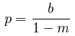  This can be seen graphically from the graph at the right. The black line is the diagonal line g(p) = p and the red line is the function f(p) = m p + b. Recall that an equilibrium point is a point at which these two lines intersect. If m is not 1 then these two lines are not parallel and they intersect at one point. This point is marked in blue on the graph. | 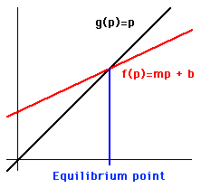
Proof:
We can prove this theorem algebraically by solving the equation
p = f(p)
as shown below.
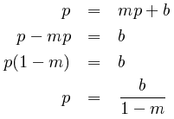
In an earlier section we discussed supply and demand models for the fluctuation of prices. In one of those models we worked with the supply and demand functions
S(p) = 1000 p - 400
D(p) = 1000 - 500 p
and the dynamical system
p_{n} = p_{n-1} + k (D(p_{n-1}) - S(p_{n-1}))
where the positive constant k depends on the kind of marketplace we are studying. In a volatile marketplace where prices respond quickly to an imbalance in supply and demand, k is relatively large, but in a more conservative marketplace where people are slow to change, k is relatively small.

- Verify that the dynamical system above is a linear dynamical system. Compute its equilibrium point using the theorem above and verify that it is the price at which supply and demand are equal.
- Describe the behavior of this model for various different initial prices when k=.0001.
- Describe the behavior of this model for various different initial prices when k=.0012.
- Describe the behavior of this model for various different initial prices when k=.0014.
- Summarize the behavior of this dynamical system for different values of k.
answer

As you saw above, linear discrete dynamical systems can behave in some surprizing ways. Sometimes a sequence obtained from a linear discrete dynamical system approaches its equilibrium point directly; sometimes it bounces around the equilibrium point and the bounces get smaller so that the sequence approaches the equilibrium point; sometimes it bounces around the equilibrium point but the bounces get larger so that the sequence does not approach the equilibrium point. Your goal in this section is to formulate and prove a theorem that determines when each of these three kinds of behavior occurs. We begin with a useful graphical tool.
Cobweb diagrams
In this section we construct the cobweb diagram for a dynamical system of the form
p_{n} = f(p_{n - 1}).
In our first example the function f(p) will be a linear function
f(p) = m p + b
so that
p_{n} = m p_{n - 1} + b
- We begin our construction of such a cobweb diagram with the graph shown at the right.  - We mark the initial point p₁ on the "x-axis" as shown in blue.  - Then we draw a blue vertical line at this point going up to the red graph of the function f(p). The blue line hits the red graph at the point  (p₁, p₂)  since  p₂ = f(p₁). | 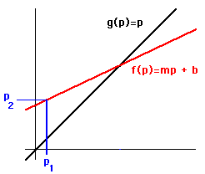
- Next we draw a horizontal line from the point  (p₁, p₂)  to the black diagonal line at the point  (p₂, p₂)  - Then we draw a vertical line to the red graph of the function f(p).  - This line hits the graph at the point  (p₂, p₃)  since  p₃ = f(p₂). | 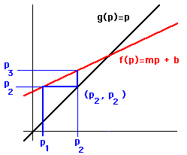
- We continue in the same way, repeating the same two steps over and over.  - Drawing a line horizontally from the red graph of the function f(p) to the black diagonal line.  - Then drawing a vertical line from the black diagonal line to the red graph of the function f(p).  Notice that in this case the "spider web" stair steps up to the equilibrium point. | 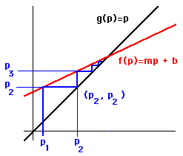

- Draw a cobweb diagram for the following linear discrete dynamical system
p_{n} = 0.80 p_{n-1} + 100, p₁ = 100.
Describe the long term behavior of this model.
- Draw a cobweb diagram for the following linear discrete dynamical system
p_{n} = -0.80 p_{n-1} + 100, p₁ = 100.
Describe the long term behavior of this model.
- Draw a cobweb diagram for the following linear discrete dynamical system
p_{n} = 1.5 p_{n-1} + 100, p₁ = 100.
Describe the long term behavior of this model.
- Draw a cobweb diagram for the following linear discrete dynamical system
p_{n} = -1.5 p_{n-1} + 100, p₁ = 100.
Describe the long term behavior of this model.
- Formulate and prove a theorem that enables you to predict the long term behavior of the dynamical system
p_{n} = m p_{n-1} + b, p₁ = a.
based on the values of the constants m, b, and a.
- We can draw cobweb diagrams for other discrete dynamical systems. The six pictures below each show the graph of a function f(p) in red and the usual diagonal line in black. We are interested in the models
p_{n} = f(p_{n-1})
with various different initial conditions. Print these graphs and use them to draw cobweb diagrams with several different initial conditions. Describe the long term behavior of these models on the basis of the cobweb diagrams that you drew.
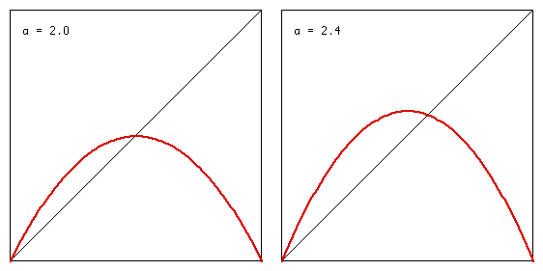
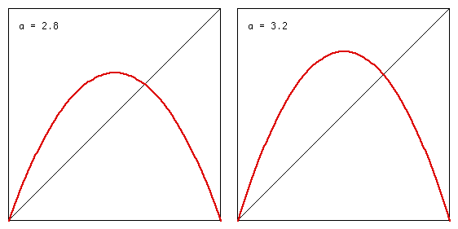
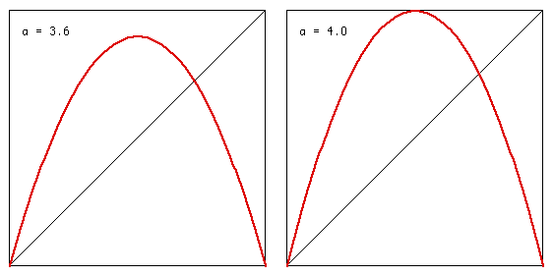

[Next section -- Logistic Models and Cobweb Diagrams]

Copyright c 1997 by Frank Wattenberg, Department of Mathematics, Montana State University, Bozeman, MT 59717

Modeling -- An Introduction
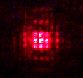
This section is a fast-paced, and we hope exciting, introduction to modeling and technology. The picture above shows the pattern created by shining the beam of a $19.95 laser pointer through a pattern of fine lines printed on ordinary transparency film by an ordinary Postscript laser printer.
Just a few years ago lasers were found only in laboratories. Now the same mysterious tools that are the stuff of science fiction and high tech eye surgery can be found in shirt pockets everywhere. To understand lasers and the seeming miracles they perform we need to understand light. This section is about light and waves, and also about other phenomena, like sound, that involve waves. It shows how modern technology -- not just graphing calculators and computers but everyday technology like portable casette tape recorders, photocopying machines, and laser pointers -- can link middle and high school teachers, students, and parents as they learn some fascinating science with incredible applications.
This course has an important subtext -- the reflective use of technology. A recently released report Does it Compute? The Relationship Between Educational Technology and Student Achievement in Mathematics from the Educational Testing Service confirms common sense --
This report presents new evidence on the effectiveness of educational technology. Analyzing data from the 1996 National Assessment of Educational Progress, it finds that the effectiveness of school computers depends upon how they are used; some uses are associated with improved student academic performance and school climate, while other uses are not.
As we use technology in this course, we discuss some of the principles behind its effective use. These principles can help you choose which technologies to use and how best to use them.
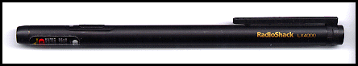
One of the most attractive uses of computers is for virtual or simulated experiments. They are cheap, safe, clean, and often very compelling. Although we like simulated experiments, we also believe that real "hands-on," "bench-lab," or "wet-lab" experiments are also important. This section has both kinds of experiments. You will need some equipment.
- A laser pointer that produces a bright and very tight beam. Compare laser pointers by projecting their beams side-by-side on a light wall. Choose the one that produces the brightest and smallest dot on the wall.
- A small bright flashlight.
- The transparencies described below..
- Graph paper.
- A Texas Instrument Calculator-Based Laboratory (CBL) with two microphones and one of the TI graphing calculators.
The best way to obtain the transparencies and graph paper is by printing them yourself using a Postscript laser printer. The Connected Curriculum Project, of which this course is part, maintains a library of files that can be printed on many Postscript laser printers using either transparency film or plain paper. For this section we use two of these files. If you haven't already installed the free Adobe Acrobat Reader, you should do so now by clicking the button below and following the instructions.
Now you need to print two files. Each of these files comes in two forms -- an Acrobat file, which is the one we recommend, and a Postscript file. The Acrobat file can be printed using Adobe Acrobat Reader. The Postscript file can be printed using any one of the many standard utilities for printing Postscript files.
- Finely-ruled graph paper
[Acrobat] | [Postscript]
- You and your students can use this paper to draw graphs. Print as many copies as you need.
- Three patterns to be printed on transparency film
[Acrobat] | [Postscript]
- You and your students will use this file to do some hands-on experiments. Notice there are three copies of each of three patterns. Cut each sheet that you print into three pieces, each of which has one copy of each of the three patterns. Give each student two pieces, one printed on ordinary paper and one printed on transparency film.
You should see a pattern on your transparency film that is like the pattern shown below. Make a shadow by projecting this pattern on the wall using your small flashlight. You may need to dim the light in the room. You can do some simple experiments with this simple apparatus.
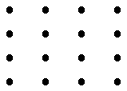
- While you hold the pattern steady, move the flashlight toward the pattern and then away from the pattern. As you move the flashlight toward the pattern, notice that the shadow grows larger. As you move the flashlight away from the pattern, notice that the shadow gets smaller.
- Now notice that the pairs of dots that are closer on the pattern produce shadows that are closer together on the wall.
The graph below represents this situation geometrically. Light radiates from the flashlight (indicated by the black dot at the right) in straight lines. The dots on the slide (indicated by the gray line in the middle of the figure) obstruct some of the light, causing shadows on the wall (indicated by the gray line at the left of the figure). Because light travels in straight lines, the shadow of each dot is on the line determined the light and the dot. The picture below is "live." You can move the light by dragging it with the mouse. Notice if you drag the light closer to the slide then the shadows on the wall spread out.
You can also move the dots on the slide by dragging them with the mouse. Notice as the dots get closer on the slide their shadows move closer on the wall.
Nothing we observed so far is surprizing, but stay tuned -- there are some surprizes in store. First we want to ask some questions that middle school geometry students can begin to answer. The underlying big question behind the small questions below is -- What is the relationship between the size of the shadow projected from a slide and the image on the original slide?
- In the figure below, measure the distance between the blue dot and the red dot on the slide (the gray line in the middle of the figure). Note that this figure is "dead." You cannot move the light or the dots on the slide around.
- In the figure below, measure the distance between the blue dot and the red dot on the wall (the gray line at the left of the figure).
- Find the ratio of the distance you measured on the slide to the distance you measured on the wall.
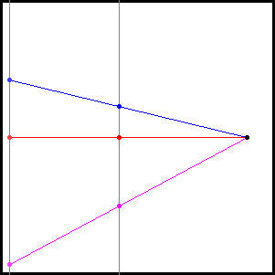
- In the figure above, measure the distance between the magenta dot and the red dot on the slide (the gray line in the middle of the figure).
- In the figure above, measure the distance between the magenta dot and the red dot on the wall (the gray line at the left of the figure).
- Find the ratio of the distance you measured on the slide to the distance you measured on the wall.
- Do you notice anything?
- Measure the distance from the light source (the black dot at the right of the figure) to the red dot on the slide.
- Measure the distance from the light source (the black dot at the right of the figure) to the red dot on the screen.
- Find the ratio of the distance from the light to the red dot on the slide to the distance from the light to the red dot on the screen.
- Do you notice anything?
With these problems as background, students would experiment using figures they draw themselves using graph paper. The idea is to let them discover the relationship between an image on a slide and its projection (or shadow) on the wall. This is a very open-ended question that students can answer with varying degrees of success.
- Some students may prove a theorem using similar triangles.
- Others may form conjectures based on many observations.
- Some students may experiment with a slide and a wall that are not parallel while others work within the confines suggested by the pictures above -- parallel slide and wall.
Students can check the theories they form using geometry against the reality of real slides and shadows. In a classroom students would be doing these experiments in small groups and talking about their theories while the teacher walked around the room interacting with different groups.
Notes on the reflective use of techology.
Even the simple observations they are making here have important practical consequences. For example, we have all seen presentations made with a projector that has been tilted by putting books under the front so that the projected image is high enough on the screen. The projected image is distorted -- wider at the top than at the bottom. The reason is that the slide and the screen are not parallel. Based on their work above, middle school students can suggest how projector manufacturers might try to solve this problem.
We have completed our first model for the behavior of light and shadows. We can't actually see what is happening between the light source and the slide and then between the slide and the wall but we have formed a mental picture or model of what is happening and that model enables us to make predictions that can then be verified or contradicted by experimental evidence. This is the modeling cycle --
- Begin with observations.
- Based on observation, construct a mental image or model.
- Use the model to make predictions and test those predictions by doing new experiments.
- If necessary, revise the model.
- Repeat the last two steps above, as necessary, to obtain better models.

[Continue]

Copyright c 1999 by Frank Wattenberg, Department of Mathematics, Montana State University, Bozeman, MT 59717

Mathematical Modeling
Unit III, Focus on Mathematical Models. In Unit I, Witchcraft in Salem Village, we were trying to understand the past, in Unit II, Earnings and Discrimination, the present, and in this unit, Unit III, Population and Resources, we are interested in predicting the future. We are interested in questions, such as: 'What will population levels be like 20 years from now?' 'Will resources keep up?' 'Can we make a better future by our actions today?' Such are the questions, and we'll try to answer them by using mathematical models.
Examples and Objectives of Mathematical Models. What do you think of when you hear the words, "Mathematical Modeling?" What are some examples of mathematical models? Click below for responses of students:
?
General weather forecasting, global warming, flight simulation, hurricane forecasting, nuclear winter, nuclear arms race, ... might come to mind as examples of large mathematical models with a large potential impact on us all. Mathematical models are also used to describe traffic flow, stock market options, predator-prey relations, and techniques of search.
What are the objectives of mathematical modeling? Forecasting the future, preventing an unwanted future, and understanding various 'natural' and unnatural phenomena are some possibilities expressed in very general terms. These might all be put into the category of problem solving by using mathematics to mirror an aspect of the world.
Example of Model | Objective | Overarching Objective
Weather | Prediction | Explanation  and  Understanding
Flight Simulation | Training | Explanation  and  Understanding
Nuclear Arms Race | Strategy Development | Explanation  and  Understanding
Traffic Flow | Regulation | Explanation  and  Understanding
Predator-Prey | Management | Explanation  and  Understanding
It's important not to confuse the mirror with what it's mirroring. As the linguist S.I. Hayakawa put it: 'The symbol is NOT the thing symbolized; the word is NOT the thing; the map is NOT the territory it stands for.' In the same vein, the model is NOT the real-world.
The Example of Malthus' Modeling. An example of a simple mathematical model, but one that has had long-term effects, is in the Malthus lecture: Malthus assumed that population would grow exponentially while subsistence would grow at best linearly. From these assumptions, Malthus derived mathematical consequences and proposed policies to try to prevent, or at least soften, the consequences.
Below is a schematic for a general mathematical modeling framework and, following the schematic, what Malthus' model and his proposal look like in that framework.
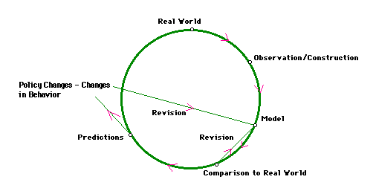
Real World: Lots of stuff going on. The French Revolution a decade ago - Ottoman Empire in decline - East India Company entrenched in South Asia - Population growth generally considered good by European intellectuals - Rapid population growth in the resource-rich United States.
Observation (construction): Through his lens of experience, goals, and intellect, Malthus observes or constructs the idea of hard times, of misery and vice. He'd like to do something about these problems. Lots of stuff is ignored.
The Model and Its Formulation:
Focus/Variables | Malthus has to decide on what his focus should be and what aspects of the real world he should ignore. He picks just two variables to work with, ignoring all else.
Assumptions | He makes assumptions about the rates of change of his two variables.
Derivations | He draws conclusions purely from the mathematics.
Predictions/Comparison to Real World: Now Malthus interprets his mathematical conclusions in terms of the real world and compares the real world to the model. Well, ideally, he would do that. But, he doesn't live in an information-rich age, and he's dealing with lengthy time spans, so he can't make such comparisons very easily.
Revise Model: If he did this, he didn't tell us about it.
Policy Changes: On the basis of his model, Malthus makes some recommendations concerning agricultural, labor, and manufacturing policies, personal restraint, and public assistance policies.
Looking at Malthus' model more closely, we see the following:
Population
Birthrate - Deathrate = fixed percent of population per unit time
Food
Agricultural Growthrate = fixed absolute amount per unit time
Population and Food Supply are both determined by rates of growth - The rates of growth are unaffected by anything, except for the modeler's (Malthus') assumptions - a sort of 'invisible hand' (using the words of Adam Smith, but in a context other than Smith intended).
What to Focus on: A Critical Choice in Modeling. An early mathematical model was formed for the psychology of perception.Things to include or ignore: Whether the perceiving was going on inside or outside, if inside, what size the room is, the temperature, noise level, type of stimulus, distance from the stimulus, length of the stimulus if it is a card, color of the stimulus card, shortest perceptible difference in the length of the stimulus card, ... . By focusing on just two variables, (Magnitude of the stimulus and the least perceptible difference in the magitudes of the stimuli) the concept of 'just noticeable difference' was constructed and the Weber-Fechner Law formulated.
Start Simply. If you were going to model population growth, what factors or variables would you want to include? (We'll come back to this question near the end of class.) Obviously, a lot of potentially valuable factors related to population growth have been left out. However, the Malthus model illustrates a principle for beginning a mathematical model: Start simply - then gradually add complexity, so long as complexity also adds insight.
To see be more precise about the process of modeling, including the revision part, let's look at the model formulation, guided by Lab 1 and the modeling software Stella.
Decide on the variables. In Lab 1, we choose at first two variables, Population and Births (per year), with Population represented with the Stella idea of a stock and Births per year represented with the Stella idea of a flow. Time is also a variable, but it isn't explicitly controlled in any way. Stella assumes that all models involve time, and we choose Stella as our model-creating tool. The initial Population is assumed to be 1,000, and Births per year is assumed to be 200. The interrelationship between the two variables is:
Population at a particular point in time | is | Population in the previous year + Births
Symbolically, in Stella language this looks like:
Population (t) = Population (t-dt) + Births per year * dt
INIT Population = 1000
INFLOWS
Births per year = 200
So, we have a very simple model that we can compare to reality. How do they compare. Well, if we run this Stella-implemented model, we see the linear growth of population over time. What we actually have is a model, supposedly for population growth, that matches Malthus' model for food growth.
We know that we have at least omitted a very obvious variable: Deaths! We could make our model a little more complex by adding a Death variable, represented in Stella as a flow away from Population.
Population at a particular point in time | is | Population in the previous year + Births - Deaths
If Deaths per year is assumed to be 100, we get symbolically,
Population (t) = Population (t-dt) + Births per year * dt - Deaths per year * dt
INIT Population = 1000
INFLOWS
Births per year = 200
OUTFLOWS
Deaths per year = 100
The Stella Diagram is
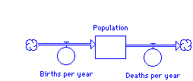
However, the graph of Population over time is still a linear one, just increasing at a constant absolute rate that is less than before. Can we do better?
Add Complexity. A key point to Malthusian growth is the idea of proportional or percentage growth, but the models thus far are assumed to have constant absolute growth rates. To introduce percentage growth, think about the increase in population when that increase is proportional to the population level itself. In other words, the increase is dependent upon two things: The proportion and the Population.
Rather than having Births determined by an 'invisible hand,' we'll have it determined by a fixed proportion and by the Population itself. To do this in Stella, introduce a converter, called Per Capita Births per year, which will be constant. Then draw connections from Per Capita Births per year and from Population to the flow Births per year, so that the diagram looks like:
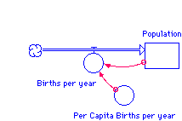
Do the same sort of thing with Deaths, making it dependent upon a constant Per Capita Deaths per year and upon Population. Now the diagram looks like:
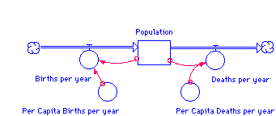
Now if we put in some reasonable numbers for Per Capita Births per year and Per Capita Deaths per year and run the model, we get a graph that is an exponential one. How does this compare to Malthus? How does it compare to our knowledge of past population growth?
Well, the model pretty well captures Malthus' ideas about population growth, but it turns out not to fit well with the data on population growth either on a world-wide basis or looking at smaller segments, say by country or region of the world. This isn't surprising, since we haven't taken any real-world features into account, other than the propensity of populations to grow!
We'll put in one last factor to try to make the model more realistic, leaving it to your laboratory work to take into account food, agricultural innovation, fertility rates, education, social security systems, etc. This last factor is the idea of a carrying capacity. It seems reasonable that our earth and solar system have some limit to the population it can support. If so, it has a carrying capacity, or maximum number of individuals that can survive on the planet.
The previous model is extended by adding a converter called Carrying Capacity, which is a (pretty big) constant. It is connected to Births per year, so that the diagram is:
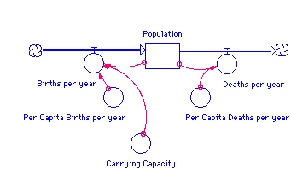
The equations for the model are:
Population (t) = Population (t-dt) + Births per year * dt - Deaths per year * dt
INIT Population = 1000
INFLOWS
Births per year = Per Capita Births per year * Population * (Carrying Capacity - Population)
OUTFLOWS
Deaths per year = Per Capita Deaths per year * Population
[Note on the term 'Per Capita Births per year' in this model that includes Carrying Capacity.]
Thus, the number of births per year is assumed in this model to be jointly proportional to the population and how close the population is to carrying capacity. When population is graphed against time it is an elongated, roughly S-Shaped curve shown below: (Population in billions, time in tens of years)
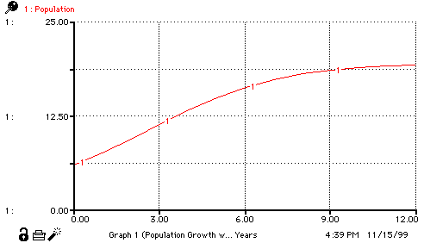
Does the Model Explain? Is the graph above consistent with Malthus? Other population data? What is the significance of the flat growth for the latter portions of time? The graph does bear some resemblance to the graph distributed in the Malthus lecture. (You can obtain this graph at the United Nations Population Information Network.)
Although the graph above is not consistent with Malthus' assumption about population growth having a constant doubling time, it perhaps captures some of the spirit in the following way: There is early on an increasing rate of growth as the graphs 'curves upward.' The fact that the graph increases at smaller and smaller rates of growth as it approaches a carrying capacity is possibly what Malthus had in mind by the term 'misery.' This slow approach to a carrying capacity is perhaps the result of war, pestilence, and starvation as more and more people contend for the resources that are now at their upper bound.
What is clear is that even if the graph were a good depiction of actual world population growth, it doesn't explain much. The dynamics of population growth remain a mystery. None of the dynamic interaction of the factors related to population growth are either assumed in or deduced from the present model.
So, let us turn to brainstorming other factors and variables to add to the model.
Brainstorming The Choice of Factors to Include when Modeling Growth of Populations. If you were going to model population growth to explain the dynamic interaction of variables involved with growth, what factors or variables would you want to include? Click below for student responses:
?
A Note on the Idea of Parameter.The notion of parameter is inherent to mathematical modeling. Roughly speaking, the parameters of a model are the constants involved in the model.
For example, we initially set Births per year equal to a constant, and we could have set that constant equal to anything we wanted. For that reason, Births per year was a parameter in the initial model. Once we changed the model by adding Per Capita Births per year and set Births per year equal to the product of Per Capita Births per year and Population, Births per year was no longer a parameter, but Per Capita Births per year became a new parameter, which we could set equal to something like 0.03. Introducing Carrying Capacity into the model introduced yet another parameter into the model.
Values for the parameters of a model are usually decided upon by collecting data or experimenting. However, values may be set in any way the modeler wants and the resulting model 'run' to see what the consequences are. The ability to experiment in this way is a very useful property of a mathematical model.
The Values of Mathematical Modeling.
1. | One is forced to choose what to focus on. You must prioritize factors.
2. | The modeling process helps make thoughts more precise.
3. | A model helps one go beyond the surface of a phenomenon to an understanding of mechanisms and relationships.
4. | One can play out different scenarios, modifying assumptions, initial values, and values of parameters, to see the resulting effects.
Problems Associated with Mathematical Modeling.
1. | The model doesn't address what you want to accomplish.
2. | The model is very sensitive to initial conditions or to the values of parameters.
3. | The model creates a mathematical solution to a problem that doesn't lend itself to a mathematical solution.
4. | The model is too simple to mirror adequately.
5. | The model is too complex to aid understanding.
6. | The results are too technical to communicate.
7. | The results aren't in a form that can be implemented.
8. | Resources aren't adequate to implement a suggested solution.

