Solving a Quadratic Equation
using –b Formula

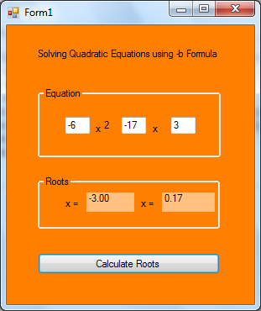

Dim A, b, C, Root1, Root2 As Single

Private Sub btnRoots_Click(ByVal sender As System.Object, ByVal e As System.EventArgs) Handles btnRoots.Click
A = Val(txtA.Text)
b = Val(txtB.Text)
C = Val(txtC.Text)
Root1 = (-b + (((b ^ 2) - 4 * A * C)) ^ (1 / 2)) / (2 * A)
Root2 = (-b - (((b ^ 2) - 4 * A * C)) ^ (1 / 2)) / (2 * A)
lblX1.Text = FormatNumber(Root1, 2)
lblX2.Text = FormatNumber(Root2, 2)
End Sub

