Work Experience
Assignment: Software Development Industry in Ireland

Research
Use www.google.ie and search for “facts on software development industry Ireland” or “facts about software development industry ireland”
Search under the following :-
- Brief history/introduction of the Software Development Industry in Ireland
- How many people are employed in the sector
- Is the industry growing and if so by how much
- Future of the Software Development Industry
- Growth Areas
- Qualifications required for employment area of your choice in SD Industry
- etc
Having completed your research highlight the important points of your research and write the report in your own words using the facts acquired in your research.

Useful websites
Software Development
http://www.altassets.com/private-equity-knowledge-bank/country-focus/article/nz3584.html

Web Development
http://business.ezinemark.com/developing-trend-of-website-design-in-ireland-16c3d1c2979.html

Game Development
http://www.gamedevelopers.ie/features/viewfeature.php?article=47

Technology in Ireland
29 May 2001. Source: Delta Partners. Dermot Berkery
Since 1994, the number of technology companies in Ireland has increased by over 250 per cent. This has contributed to an increase in Irish private equity dealflow. Private equity firm Delta Partners looks at the dramatic growth of the sector, details the types of investors in the market and the routes that institutional investors can take to participate in it.

The technology sector in Ireland has seen unparalleled growth, particularly since 1998. Together with Israel, Cambridge and Munich, many large European investors see their most interesting investment opportunities in Ireland. Software rather than hardware predominates. A large number of start-ups operate in specific sub-sectors such as security, payments, wireless infrastructure and silicon design. The worst excesses of the e-commerce era were largely avoided as the small size of the domestic market meant that Ireland was not viewed as a good launching pad for large multi-country e-commerce rollouts. While the downturn in the public markets has tempered private company valuations, it hasn't tempered the flow of investment into technology start-ups.
The investment pattern is well formed. Local venture capital firms with very strong networks fund Irish start-ups to the point where the investment rounds become significant (€5-10m or greater). At that point, overseas investors - generally from Britain or Benelux - are brought in, typically via relationships with the local VC firms. Exits have been through trade sales to large technology companies, (mainly US-based) and, to a lesser extent, through public offerings, which normally involve a dual listing on NASDAQ and the Irish Stock Exchange.
Until 2000, only local pension funds and banks invested in Irish VC funds. Since the start of 2000, this has changed. The new funds raised by the Irish VC firms have a familiar set of US and European investors.
Why is Ireland such a vibrant market for technology investing?
First, some facts to put the Irish situation in perspective. Ireland is the largest exporter of software in the world, even ahead of the US. Admittedly, much of the exported software is from international technology companies based in Ireland. But there has still been huge growth in the domestic sector in recent years. The number of Irish technology companies has risen from an estimated 450 in 1994 to 1,200 in 2001. At a more granular level, the signs for the future are good. Ireland graduates 70 per cent more science and engineering students per capita than any other country in the OECD and the Irish government has just committed €1bn to basic research in IT and life sciences.
The underlying factors driving the market are as follows:
- Extensive presence of large technology multinationals - A very large percentage of people employed in the private sector work for high-technology development companies. While Ireland has roughly one per cent of the EU population, it receives 33 per cent of US IT investment in Europe. Most of this investment is into software development units, rather than manufacturing facilities or hardware development. The list of high-tech companies represented in Ireland is long - Motorola, Ericsson, Lucent, Nortel, Analog Devices, Xilinx, Microsoft, Tellabs, Sun, to name a few. The presence of multinational technology companies is critical for two reasons. Firstly, it creates numerous spin-offs from development teams working on interesting problems. Secondly, it produces large numbers of skilled business development and marketing people who already have strong international networks.
- Critical mass in interesting sub-sectors - While Ireland's overall strength is in software development, especially in communications, there is now a critical mass of companies in sub-sectors such as security, payments, silicon design and wireless infrastructure. Examples include:
  - Payments: Trintech, Artic Web, Cardbase
  - Silicon Design: Parthus, Toucan Technologies (sold to PMC-Sierra), Massana
  - Security: Baltimore Technologies
  - Wireless infrastructure: Aldiscon (sold to Logica), Apion (sold to Phone.com), Xiam
Critical mass in these sub-sectors will stimulate the future flow of opportunities.
- Early successes - The successful IPOs by companies such as Iona Technologies, Baltimore Technologies, Riverdeep, Trintech, Smartforce, etc. have created role models across a wide variety of technology sectors.
Who are the players?
The players in the Irish market can be classified into a few different groupings. There are the major local VC firms, seed capital providers, brokers, large investment VC firms without a local base, but that are quite active, and, finally, Enterprise Ireland.
- Major local VC firms - The major local VC firms are Delta Partners, ACT, Trinity Venture Capital, ICC and the Irish branch of Cross Atlantic Technology Partners (a US headquartered firm). All invest in technology companies and some also invest in traditional companies. Within technology, each company has a relatively different investment strategy, either by stage of development or by size of round, etc, but all are interested in strong early stage companies irrespective of the sector. A clear trend among some is to make larger commitments to individual companies. The major advantage that each VC firm exploits is the strength of local relationship networks.
- Seed capital providers - Given the general strength of the Irish economy since 1995, and the wealth created in the technology sector, some of the capital amassed has been recycled into very early stage investing. Wealthy private investors investing directly or via small commingled funds (values of EUR5m) have been very active in the market, particularly up to Summer 2000. This source of fund is much less of a force in the market today.
- Stockbrokers - At the height of the market, brokers had a very strong presence, particularly given the large pools of capital available from their private clients' divisions. Some deals bypassed venture capital firms and were funded directly by private clients of brokers. This is no longer the case.
- Large international VC firms active in Ireland, but without a local base - While the vast majority of large European investors will have looked at deals in Ireland, there are a number that appear to view Ireland as a core market for sourcing investment opportunities. These include 3i, BancBoston Capital, Vertex Management, Intel Capital. These firms are often most interested in companies seeking second round investment that have some level of track record. Where they come across a company seeking first round funding, they typically aim to co-invest with one of the local Irish VC firms, in particular to ensure effective ongoing management of the investment. Some of these firms are developing an on-the-ground presence in Ireland.
- Enterprise Ireland - When looking at Ireland, it is important not to underestimate the role played by Enterprise Ireland, the state body supporting domestic industry. Enterprise Ireland makes seed investments in companies, often alongside the VC firms, and invests in funds as well.
Dermot Berkery joined Delta Partners as a general partner at the start of 1999. Prior to this he was a senior manager with McKinsey & Co. From 1995 to 1998, he helped Irish companies in a range of sectors to develop and pursue accelerated growth strategies. Before McKinsey, he was a senior in the corporate financial services division of Arthur Andersen in Dublin and London, where he specialised in financial restructurings. A graduate of University College Dublin in Commerce, he holds an MBA with distinction from the Harvard Business School and is qualified as a chartered accountant. He can be contacted at Dermot@delta.ie

Delta Partners is a European venture capital firm based in Ireland, which focuses on early stage technology investing. With over $100m under management, the team has made over 30 investments in the following technology sectors: communications - internet - software - life sciences

The Games Industry in Ireland 2009

This feature reports on a survey conducted by Aphra Kerr, based at the National University of Ireland Maynooth, and Anthony Cawley, University of Limerick, over the summer of 2009. It explores the demographics and functions of game companies on the island of Ireland and traces their geographical spread.
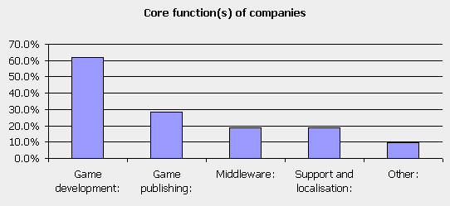
Note: This article is also available as a downloadable PDF file here.
Methods
The survey was set up using Survey Monkey. The draft questions were piloted with a number of people who are familiar with the industry. A database of companies was developed, and the survey was publicised on gamedevelopers.ie and at the Irish Game Dev. 2.0 event in the Science Gallery at Trinity College Dublin in May 2009.
Companies whose main function was game related were invited to participate. In total, thirty-three invitations were sent out by post and e-mail to companies in the Republic and the North of Ireland.
Ten companies failed to respond, while two companies failed to complete the survey. The survey, therefore, is based on responses from twenty-one companies on the island of Ireland. It is in our view a comprehensive view of full time game companies in Ireland.
Numbers employed and occupation
In March 2002 Aphra Kerr launched a report called 'Loading …Please Wait: Ireland and the Global Games Industry'. The research was based on fifteen face to face interviews, seven of which were with people in the Irish games industry, including Funcom, Havok, Kapooki, Eirplay and Vivendi. The rest were with government agencies, retail and media commentators.
Kerr's 2002 report estimated that there were just over 300 people employed in the games industry in Ireland in 2002. The bulk of these, 165, were employed in localisation, with another one hundred or so in middleware and animation services, and the remainder in content development.
A Forfás study on the industry the following year estimated that there were 400 people employed across twenty-two companies (2004: 5). At the time the wider digital media industry in Ireland was estimated to consist of 280 companies employing from 4,000 to 4,500 people.
Our 2009 survey found that the games industry has expanded significantly in the past eight years. The twenty-one companies who responded employ a total of 1,277 full time permanent employees plus 170 contractors and twenty-two freelancers. This gave a total of 1,469 and represented growth of over 400% in seven years.
Of these, almost 900 are employed in 'other' areas, including online customer/player support, while a further 198 are employed in quality assurance. Of the balance, 104 are employed in management, seventy-two in programming, fifty-nine in localisation, and a further sixty in art, design and audio. Twenty-six are employed in marketing.
The areas of most dramatic change are online customer support and localisation. Online support was not even in evidence at the time of the last survey and has grown rapidly. Localisation, meanwhile, has declined by almost a half. Growth in programming and art jobs has increased steadily, as has employment in management and marketing.
Size, age and ownership of companies
The last five years has been a period of growth in the establishment of companies in Ireland. Significantly, thirteen of the companies who took part in the survey had been established in the last two to five years. Only two companies were older than ten years, and four respectively had been formed in the last year and were between six and ten years old.
Indigenous game development companies tend to be small, with less than fifty employees. Indeed, the majority of indigenous companies that responded to the survey employed less than fifteen (n=8).
Foreign owned multinationals tended to operate in different functional areas and employ greater numbers, i.e., from thirty to fifty employees, with one or two examples employing over 150. A couple of newly established multinationals have fewer than ten employees. The two companies which have existed for more than ten years were foreign owned multinationals.
While the two oldest companies were foreign owned, and operating primarily in support and localisation, the four companies in the six to ten year old category were Irish owned and were active in middleware, content development and publishing for mobile/web platforms.
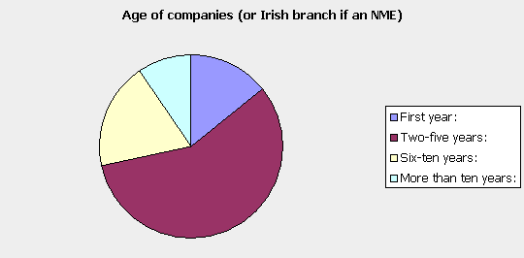
Function of the company
Thirteen companies or just over 60%, replied that game development was their core function. A further 30% identified game publishing. The remainder were involved in support and localisation (n=5), middleware (n=4), and two stated other functions.
Most companies focused on a single function, with only one company involved in development, publishing, support and localisation. A further two companies were involved in development and support and localisation.
Platforms
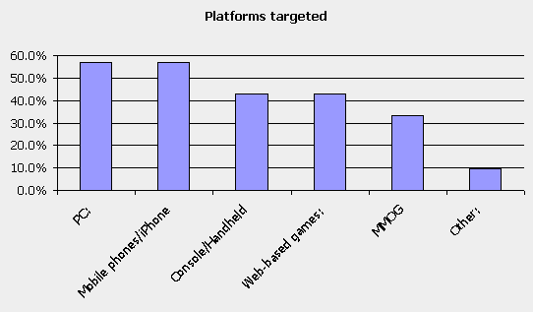
Many companies are working across multiple platforms, particularly those involved in support, localisation and middleware. Smaller, indigenous companies who are involved in game development tend to focus on PC, web and mobile platforms. There are two indigenous game development companies working on console/handheld game development.
PC/Mac are the most popular platforms, followed by mobile/iPhone, and then console and web based games. Eight companies are involved in massively multiplayer online games.
Employment demographics
Females constitute 13% of the total numbers employed, although if we take out those involved in online community support they constitute just under 7%. Employment areas where women tend to be found are quality assurance, administration, management and localisation.
Without customer support the overall percentage would be lower than the UK average for women employed in the computer games industry (12% in 2006, according to Skillset) and much lower than the average for the media industries more generally (38% in 2006, ibid).
Almost 43% of employees in these companies are aged between twenty-six and thirty-five years, with a further 30% aged between eighteen and twenty-five years. By nationality, the greatest number of employees are German (n=333), followed by Irish (n=297) and other European (n=248), i.e., not French, German, Spanish or Italian. The fourth largest nationality group is British.
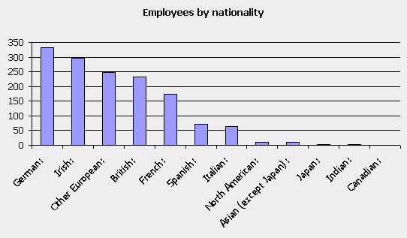
Location in Ireland
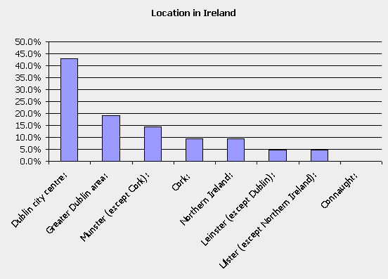
Thirteen of the companies who responded were located in the greater Dublin area, with nine of these stating they were located in Dublin city centre. A further five were located in Munster, with three in Ulster.
Almost half of companies had an office outside of Ireland, with a majority of these located in Europe, followed by the United States. Canada and Asia (except Japan) were joint third. Two thirds of companies had located their headquarters in Ireland. Of the third that did not, most of these (n=6) had headquarters located in the United States.
When asked why they were located in Ireland, the companies provided an interesting mix of responses. While availability of skilled labour was the most significant reason for almost half of respondents, this was followed closely by an ability to attract talent, even if it wasn't available locally, i.e., access to Europe and an English speaking workforce. In addition, four companies cited grants and financial incentives, and one identified links to universities.
A significant issue mentioned was the fact that people were living in Ireland when they founded the company. For some, even if they subsequently moved to live elsewhere the company remained registered in Ireland.
The IDA and Enterprise Ireland were the main public sector bodies contacted for finance and advice, with three companies seeking advice from the Digital Hub and two from County Enterprise Boards. More than half of the companies had not obtained advice or finance from a public sector body.
Client markets
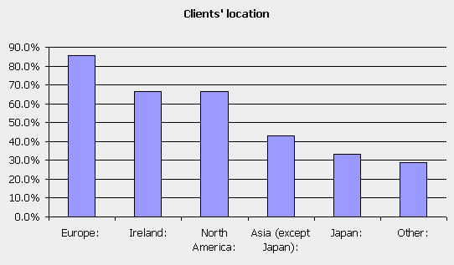
Given the small size of the Irish market it is not surprising that 86% of companies were selling into the European market (n=18), followed closely by the North American market (n=14) and the Irish market (n=14).
A relatively large number of companies were selling into Asia (except Japan) (n=9) and Japan (n=7), as well as sales to Australia, Latin American and Africa.
Twelve companies signaled that they engaged in outsourcing, with QA/localisation and content development the most likely areas to be outsourced. These functions tended to be outsourced elsewhere in Europe, Ireland and the UK.
By contrast, membership of international and national professional associations was low. A small number of companies (n=6) have employees who are members of the International Game Development Association (IGDA). One is linked to IBEC and one to Mobile Entertainment.
Qualifications and Links to education
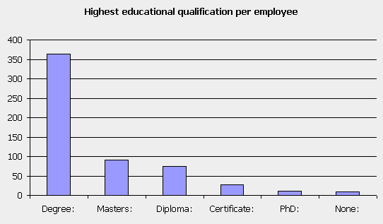
The data for educational attainment is rather partial because figures were given for only one third of employees. Some respondents stated that this data was difficult to collate. The data provided, however, would suggest that a degree and above is the norm, although there are some employees with certificates and diplomas.
Good linkages exist between the third level sector and the industry, and respondents indicated a willingness to improve them. Just over half of companies offer internships to students. Five are involved in giving guest lectures, and four have been involved in course development. Nine companies would be interested in greater involvement and links with Irish universities and colleges.
Final remarks
We believe that this survey provides a comprehensive view of a growing Irish games industry. The Irish games industry is networked internationally with clients in Europe and the United States, and with a significant number of companies linking into Asia.
The Irish industry profile is growing internationally, helped in no small part by the success and acquisition of indigenous middleware companies like Havok and Demonware but also by the arrival of multinational players such as Gala Networks, Goa, Blizzard and Activision.
In the last seven years there has been a significant shift in the size and focus of the games industry. Employment has grown by about 400%, with an important expansion in online customer support. Localisation, while remaining important, has declined in employment terms within Ireland. Content development, while not the main employer, is a core function for many companies.
If we examine the industry across the value chain it is clear that some functions are more employment intensive than others. This is particularly the case in relation to publishing, localisation and online support. Game development companies tend to be much smaller in size and more focused on that particular function.
Human capital and labour are clearly important issues for these companies. Given the development of a range of new third level courses in the country in the past seven years it will be interesting to see if locally available talent will replace ability to attract talent in the coming years.
The location of companies largely in the cities of Dublin and near Cork may be related to this ability to attract talent. Ability to work across multiple platforms and linguistic skills are also clearly of importance to existing companies.
Issues that will need to be addressed include the gendered nature of the industry and the fact that few women are employed in core programming and art/design functions.
Further, it is significant that half of respondents have not had support from local enterprise development agencies. There is a need to support companies into middle age (i.e., beyond five years). Further analysis of the data will, we anticipate, lead to further insights.
We hope that this survey will contribute to a better understanding of the place of the Irish games industry within the local digital media industry and globally within the games industry.
Related documents
Forfás (2002) A Strategy for the Digital Content Industry in Ireland. Available at http://www.forfas.ie/publication/search.jsp?ft=/publications/2002/Title,882,en.php
Forfás (2004) Electronic Games Study. Unpublished internal report.
Forfás (2006) International Digital Media Industry: Implications for Ireland. Available at http://www.forfas.ie/publication/search.jsp?ft=/publications/2006/Title,757,en.php
Kerr, A. (2002). Loading... Please Wait. Ireland and the Global Games Industry (No. STeM Working Paper No 1). Dublin: STeM, Dublin City University. See http://www.stem.dcu.ie/
Kerr, A. (2003). Live Life to the Power of PS2: locating the digital games industry in the new media environment. Irish Communications Review, 9. See http://www.icr.dit.ie/
Kerr, A. (2006). The business and culture of digital games: gamework/gamplay. London: Sage.
Bios:
Aphra Kerr is a lecturer in the Department of Sociology at the National University of Ireland Maynooth. Her research focuses on the production and consumption of digital media and in particular digital games. See established www.gamedevelopers.ie in 2003. For more see http://sociology.nuim.ie/AphraKerr.shtml
Anthony Cawley is a research scholar in the Institute for the Study of Knowledge in Society (ISKS), University of Limerick. His research interests include innovation in digital media and online journalism. For more see www.ul.ie/isks.

